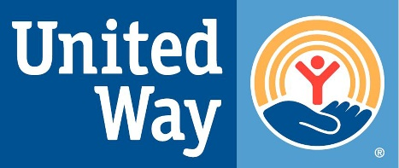
FOR IMMEDIATE RELEASE
United Way of the Virginia Peninsula
Two City Center, 11820 Fountain Way #206
Newport News, VA 23606 USA

Media Contact:
Steven S. Kast, President & CEO
United Way of the Virginia Peninsula
757.873.9328
skast@uwvp.org

Feminine Hygiene Drive-Thru Event Raised Over $15,000 Worth of Products
March 29th, 2021, Yorktown, Va. – On March 27th, 2021, United Way of the Virginia Peninsula’s women’s group, Women United, hosted a drive-thru feminine hygiene drive. Located at C.A. Barrs Contractors Inc. in Yorktown, VA on a beautiful Saturday, this event raised over _______ products worth over $15,000 to help over 4,000 women and girls in need across the Peninsula. Representatives from over 15 community agencies picked up the donated feminine hygiene products to provide ________ products to those they serve. Gratefully receiving these items were, _________________. One agency representative shared that their female clients often cry when they receive feminine hygiene products. This shows the importance of these products and the difference it makes in the lives of those in need.
“Robin quote”
Steve Kast, President and CEO of United Way of the Virginia Peninsula states, “This event shows the kindness of our community, despite the hardships we have experienced over the past year. We are appreciative to live in a community that cares about the wellbeing of our neighbors in need.”
Women United’s Feminine Hygiene Drive also included items collected on an online drive leading up to the in-person drive-thru. This drive accounted for approximately half of the overall donated items.
###
About United Way of the Virginia Peninsula
United Way believes we can achieve more together than any of us could do on our own. That's why our board is committed to our mission of uniting people, organizations, and resources to improve lives in the Virginia Peninsula. By fostering community partnerships, we can champion shared goals and align resources to deliver innovative, holistic solutions to our community's most pressing issues, with a focus on coming together to break the cycle of poverty.
Whether United Way is funding others to provide services, delivering services or coordinating collaborative programs, we are working together to create a path to stability and self-sufficiency. By focusing on the building blocks of health, education, and financial stability to create “Pathways Out of Poverty”, we don't just change lives - we change what's possible. Learn more at www.uwvp.org.
###
